

**Druva inSync**

**Plugin Configuration Guide**

Contents

Configuration Checklist 2

Configuration Details 2

Supported Collection Types 3

Data Sources 3

Requirements 4

Firewall Ports 4

Setup 4

Server Properties 4

Field Definitions 4

Troubleshooting 5

Test Connection 5

Reporting Notes 5

Technical Support 6

# Configuration Checklist

Here is a quick checklist for deployment of Druva inSync. Detailed instructions are in later sections:

* Contact Druva Support to enable the ***Events API***.
* Ensure Events API is enabled and the *Events Categories* is set to “All Events”.
* [Create and capture API credentials](https://docs.druva.com/Druva_Cloud_Platform/Integration_with_Druva_APIs/Create_and_Manage_API_Credentials) (Client ID and Secret Key):

# Configuration Details

The following is an overview of the steps to configure Druva inSync collections on your Bocada Data Collection Server:

* Contact Druva Support to enable the ***Events API*** as this feature is currently under controlled availability. Refer to Druva document <https://developer.druva.com/docs/event-apis> for detail.
* Ensure Events API is enabled and the *Events Categories* is set to “All Events”

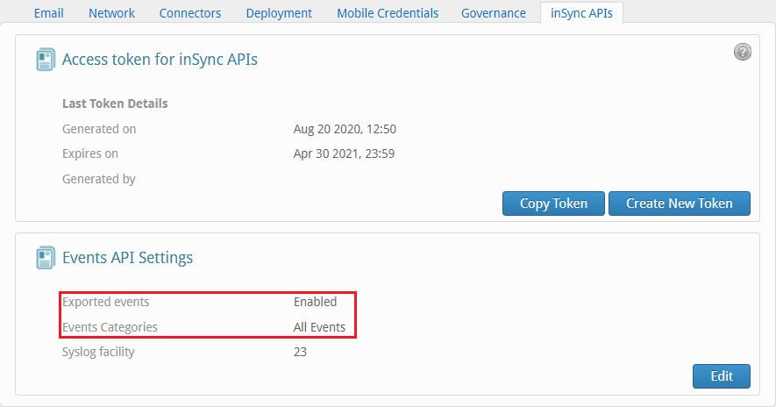

A Druva inSync Administrator with *Druva Cloud* role must enable the Events APi and set the category after Druva Support enables the feature.

* [Create and capture API credentials](https://docs.druva.com/Druva_Cloud_Platform/Integration_with_Druva_APIs/Create_and_Manage_API_Credentials) (Client ID and Secret Key):

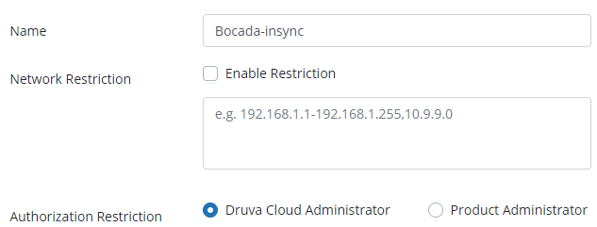

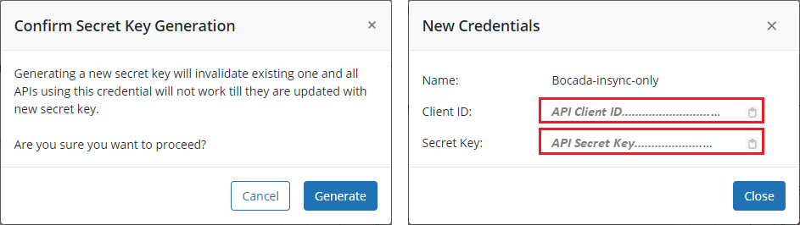

# Supported Collection Types

The plugin supports the following collection types from Druva inSync:

|  |  |  |
| --- | --- | --- |
| **Collection Type** | **Supported** | **Description** |
| Backup | ✓ | Collects transactional details about user endpoint backups. Example metrics include, start times, durations (last successful backup only), bytes, files, and errors, etc. |
| Storage |  | Collects point-in-time inventory information. Example metrics include, total recoverable gigabytes (storage), media volume count, media volume status, etc. |
| Policy |  | Collects and stores information on policy attributes, schedules, storage destinations, and backup objects. |
| In Progress |  | Collects basic information on backups that are running or have completed since the previous full Backup jobs data collection. These updates are included in the Backup updates, but are lightweight and can be scheduled more often than backup updates if needed. |

Bocada currently supports the following user endpoint backups:

* Machines
* Gmail
* Google Drive
* Exchange Online
* OneDrive

# Data Sources

The plugin relies on the following Druva inSync data sources:

* Druva inSync REST API
* Druva inSync Events API

The scope of data collected from Druva inSync is limited to what is available to the API Credentials as described in the [Druva Events API documentation](https://developer.druva.com/reference#get_eventmanagement-v2-events). See also: [Druva credentials documentation](https://docs.druva.com/Druva_Cloud_Platform/Integration_with_Druva_APIs/Create_and_Manage_API_Credentials) for Druva API credential reference.

# Requirements

This section lists requirements that must be met prior to collecting data with the Bocada plugin for Druva inSync.

### Firewall Ports

|  |  |  |
| --- | --- | --- |
| **Service** | **Default Port** | **Note** |
| HTTPS | 443 | Outbound from DCS to Druva inSync API |

# Setup

### Server Properties

Backup Server Properties determine how the plugin will interface with the Druva inSync cloud and are managed through the Backup Servers view.

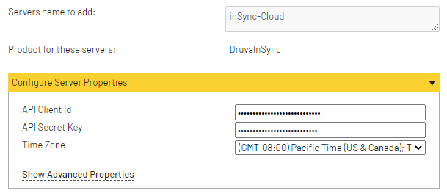

### Field Definitions

#### Server name

Enter a name for the Druva inSync Cloud that you wish to see within Bocada. Use descriptive name within Bocada to associate Druva inSync API Client ID and Secret key pair.

#### API Client Id

Enter the Client Id described in the above checklist.

#### API Secret Key

Enter the Secret Key described in the above checklist.

#### Time Zone

Select the time zone where Druva inSync server resides. This setting ensures times are displayed consistently in environments that span multiple time zones.

# Troubleshooting

## Test Connection

Test Connection is using server properties to get Druva events, check the message for the reason.

The message ‘test connection successful’ indicated events are collected successfully; otherwise the message should tell the user the specific error.

If the message is ‘no event returned’, this could be due to incorrect event API configuration. Try running data collection updates to see if any backup being collected.

If no data is collected, further diagnostic may be required, using postman for example.

# Reporting Notes

There are currently no dedicated reporting notes for Druva In Sync.

# Technical Support

For technical support, or for a copy of our standard support agreement, please contact us.

**E-mail:** [support@bocada.com](mailto:support@bocada.com)

**Support Portal:** <https://bocada-support.force.com>

**Phone:** +1-425-898-2400